Department of Computer Science and Engineering
Course Code: CSE370
Course Name: Database Systems | Semester: Spring 2026

Part A
Setting Up and Connecting to the MySQL Server
Activity List for Part A
Step 1: Go to https://www.apachefriends.org/index.html and download XAMPP for your OS.
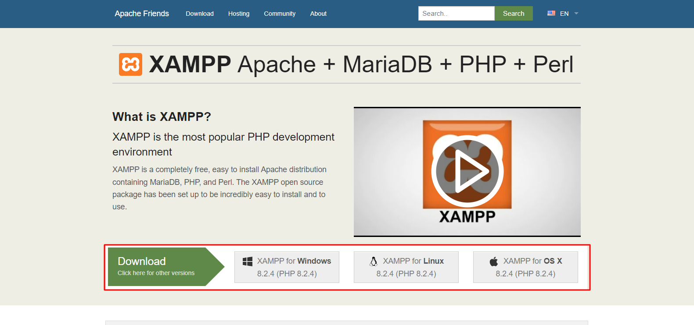
Step 2: Install XAMPP according to the installation guide.
Step 3: Open the XAMPP control panel after installation.
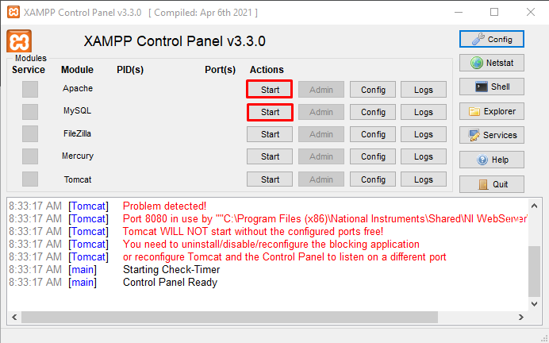
Open the control panel and click the start buttons (highlighted in red) beside Apache and MySQL.
Step 4: Click on the “shell” button on the right of the window

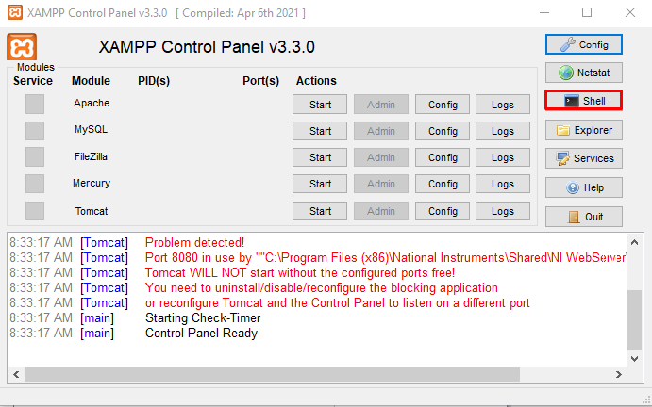

Step 5: Connect to the MySQL server
After clicking on the shell, you should see a black window. Type in the following command:
mysql -u root -p

When you are asked for a password, don't type anything just press enter. The default password for xampp is an empty string.

Part B
An Introduction to MySQL Queries
Syntax error in a query might cause the mysql> prompt not to appear after executing the query.
Solutions:
    - Typing one of the following may solve the problem
      - ');
      - `);
      - `;
      - ';
      - Or log out with ctrl+c and log in again

Activity List for Part B
- All commands are shown in the red boxes.
- In the green box, write the response you see after entering each query. Also, write the query for cases where you had to make changes.
- The part of the query in bold italic are variables, the rest are keywords. Sometimes, you might need to change the variables as per requirement.
- All new queries should be typed in the command window after mysql>

A Server can have multiple databases, for example, a movie database and a car rental database. So how can you view the list of all databases?

SHOW DATABASES;

If you want to start a new project you should create your own database. After creating check if the new database is in the list now.

CREATE DATABASE DB_Name ;

Before storing or manipulating any data, you HAVE to select the database you want to work on. All new command will take effect in selected database.
USE DB_Name ;

All data are stored in tables. Each table will represent 1 entity, for example students_info, the column of the table will be attributes of the students(e.g. student_id, name, department, cgpa, grad_date) and each row will have information about 1 single student. Each attribute has a pre-defined data type such as int, char etc.
CREATE TABLE Lab_Grades
(
std_id char(4),
name varchar(30),
major char(3),
section char(1),
days_present int,
project_marks double,
cgpa decimal(3,2),
submission_date date
);

SHOW TABLES;
You can have many tables in database, e.g student_info, teacher_info, course_info etc. So how to view the list of all tables?

You might want to check the structure of a table e.g. what columns are there, what are the data types etc.
DESCRIBE Table_Name;

std_id | name | major | section | days_present | project_marks | cgpa | submission_date
s001 | Abir | CS | 1 | 10 | 18.5 | 3.91 | 2018-09-15
s002 | Nafis | CSE | 1 | 12 | 20 | 3.86 | 2018-08-15
s003 | Tasneem | CS | 1 | 8 | 18 | 3.57 | 2018-09-18
s004 | Nahid | ECE | 2 | 7 | 16.5 | 3.25 | 2018-08-20
s005 | Arafat | CS | 2 | 11 | 20 | 4.0 | 2018-09-13
s006 | Tasneem | CSE | 1 | 12 | 17.5 | 3.7 | 2018-08-15
s007 | Muhtadi | ECE | 1 | 10 | 19 | 3.67 | 2018-09-16
S008 | Farhana | CSE | 2 | 6 | 15 | 2.67 | 2018-08-16
s009 | Naima | CSE | 2 | 12 | 20 | 3.7 | 2018-08-14
Link for Table Data: https://docs.google.com/document/d/1YYP8YpRP2gEvWFoCkp3rpkZKdR-CEjmunhR_3-9s18Q/
Now you want to insert the data above in the table you created. There are two commands: a long version and a shorter one! Insert all the data above in the table.
INSERT INTO Table_Name (std_id,name,major, section, days_present,project_marks,cgpa,submission_date) values (‘s001’,’Abir’,’CS’,’1’,10, 18.5, 3.91,’2018-09-15’);
INSERT INTO Table_Name values (‘s001’,’Abir’,’CS’,’1’, 10, 18.5, 3.91,’2018-09-15’);

So now you want to view all the data you inserted? For that we will use the select query. More on that later!

SELECT * FROM Table_Name;

Part C
SQL Alter, Update, Delete & Basic Select Queries
Task 1: Modifying Columns of a Table:
Add column project_title in the table
ALTER TABLE Lab_Grades add project_title char(10);
The data type for Project_title should be varchar(50)

ALTER TABLE Lab_Grades MODIFY COLUMN project_title varchar(50);

ALTER TABLE Lab_Grades DROP COLUMN project_title;
Now let’s delete the column Project_title

- How will you change the name of a column from submission_date to sub_date? [Google it!]

Task 2: Updating Wrong Data:
UPDATE Lab_Grades SET major = ‘CSE’ WHERE name = ‘Arafat’;
Oops! Arafat’s major is actually CSE, so update the value in the table

UPDATE Lab_Grades SET name=’Naheed’, project_marks =16 where std_id = ‘s004’ ;
Nahid’s name is misspelled and also his project marks should be updated to 16.

- What will happen if the where clause is not included in the update query, e.g . if you typed Update Lab_Grades set Major = ‘CSE’;? [Don’t try it now, just write the answer]

Task 3: Deleting Data:
Naima dropped out of the course. So, delete her data from the table.
DELETE FROM Lab_Grades WHERE Name= ‘Naima’;

- What would have happened if there was another student named Naima?

DELETE FROM Lab_Grades WHERE days_present < 8;
Delete the data of everyone who was less than 8 days present.

Task 4: Deleting Table or Database [DO NOT TRY NOW]:
DROP TABLE Table_Name;
DROP DATABASE DB_Name;
So now if you want to delete a table or database you need the following commands

Task 5: Retrieving Data from Table:
- What is the [select * from Lab_grades;] command used for?

SELECT std_id, name, project_marks FROM Lab_Grades;
Let’s say you want to retrieve only the student id, name and project marks.

Retrieve the name and total marks of students out of 25 (project + attendance)
SELECT name, project_marks+days_present*5/12 AS total_marks FROM Lab_Grades;

- The “as” keyword in the above query is known as an alias. Check out what happens if you remove the “as Total_marks” portion from the above command. State the difference below.

- Try the command below, and state what the Upper() and Lower() functions mean.
SELECT UPPER(name), LOWER(name) from Lab_Grades;

- Try the two commands below. What is the difference and why is the distinct keyword used?
SELECT DISTINCT major FROM Lab_Grades;
SELECT major FROM Lab_Grades;

SELECT * FROM Lab_Grades ORDER BY name;
Now you want to view all the details sorted by name. You can use the order by keyword

- Was it sorted in ascending or descending order? How can you sort in the opposite order?[Hint: check next command]

SELECT * FROM Lab_Grades ORDER BY name DESC, submission_date ASC;
Sort all details according to name and then by submission date. There are two students named Tasneem, observe what happens.

SELECT name,project_marks FROM Lab_Grades WHERE major=’CSE’ ;
Now, you want to view the name and project marks for only CSE students.

- Retrieve the names, days present and marks of students whose project marks are greater than 17

SELECT name,project_marks FROM Lab_Grades WHERE project_marks BETWEEN 17 and 19 ;
SELECT * FROM Lab_Grades WHERE major in (‘CSE’, ‘CS’);
Retrieve the name and marks of students whose marks is between 17 and 19
Retrieve the details of students who are majoring in either CS or CSE

- What is the “in” keyword in the above query? In the where clause, you can write the same command using the “or” and “=” operators. Try to figure it out!

Retrieve the details of the students who submitted their project in August and whose marks is greater than 18
SELECT * FROM Lab_Grades WHERE project_marks>18 and submission_date BETWEEN ‘2018-08-01’ and ‘2018-08-31’;

- How can you find the students whose Submission_date is not in August?

SELECT * FROM Lab_Grades WHERE name like ‘a%’;
Retrieve the details of students whose name start with ‘a’

Retrieve the details of students whose name contains at least 2 a’s
SELECT * FROM Lab_Grades WHERE name LIKE ‘%a%a%’;

- Try the following command and explain what happens : Select * from Lab_Grades where Name like ‘a___’; [There are 3 underscores]

Task 6: Basic Select Quiz
Go to https://sqlzoo.net/wiki/SELECT_Quiz and answer the Quiz to test your knowledge of basic select queries.

